Akarshan S

**ASSIGNMENT-3**

|  |  |
| --- | --- |
| Team ID | PNT2022TMID05721 |
| Project Name | NEWS TRACKER APPLICATION |

1) Create a Bucket in IBM object storage

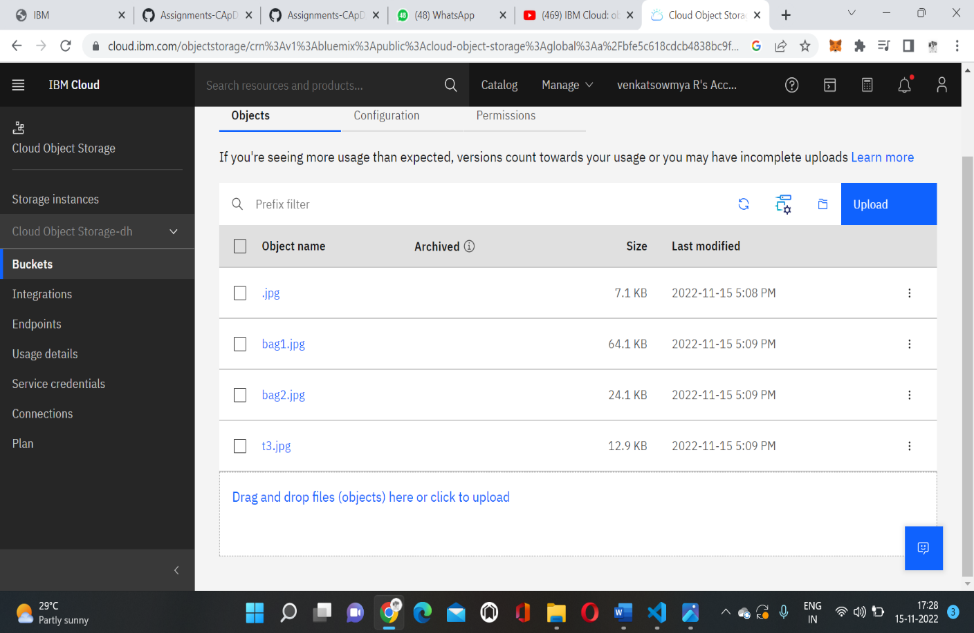

2) Upload an 5 images to ibm object storage and make it public. write html code to displaying all the 5 images.

<!DOCTYPE html>

<html>

<head>

<title> ASSIGNMENT 3</title>

<meta charset="UTF-8">

<meta name="viewport" content="width=device-width, initial-scale=1.0">

</head>

<body>

<img src= cos://jp-tok/cloud-1901/.jpg>

<img src= cos://jp-tok/cloud-1901/bag1.jpg>

<img src= cos://jp-tok/cloud-1901/bag2.jpg>

<img src= cos://jp-tok/cloud-1901/t3.jpg >

</body>

</html>

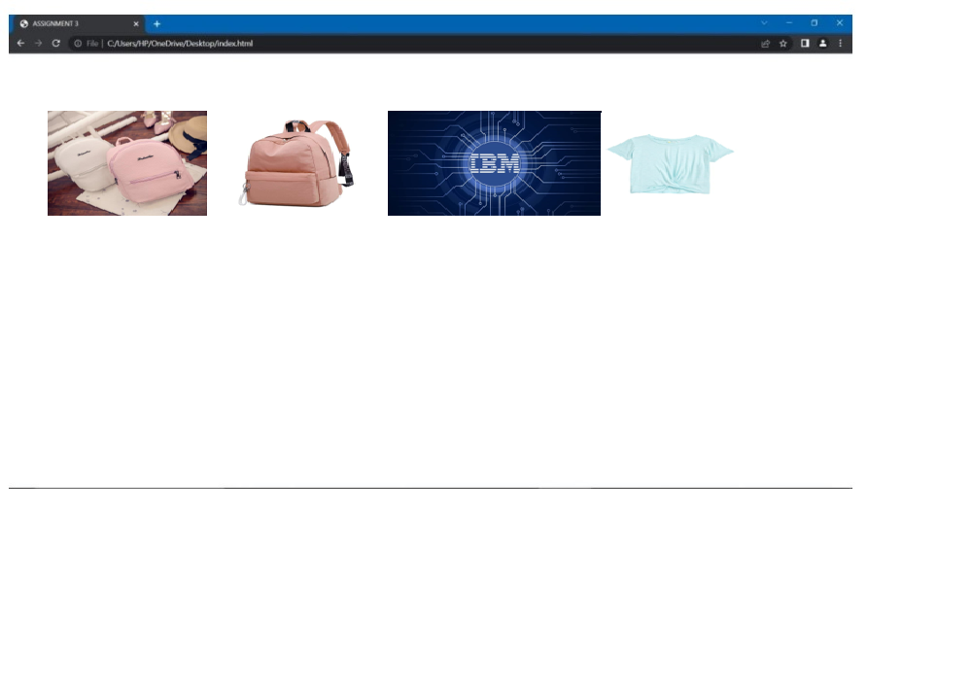

3) Upload a css page to the object storage and use the same page in your HTML code

<!DOCTYPE html>

<html>

<head>

<title> ASSIGNMENT 3</title>

<meta charset="UTF-8">

<meta name="viewport" content="width=device-width, initial-scale=1.0">

<style>

body{

style="border:rgb(15, 15, 15);

border-width:5px; border-style:double;text-align: center;font-family: Arial, Helvetica, sans-serif;

background-color:powderblue"

}

</style>

</head>

<body>

<img src= cos://jp-tok/cloud-1901/.jpg>

<img src= cos://jp-tok/cloud-1901/bag1.jpg>

<img src= cos://jp-tok/cloud-1901/bag2.jpg>

<img src= cos://jp-tok/cloud-1901/t3.jpg >

</body>

</html>

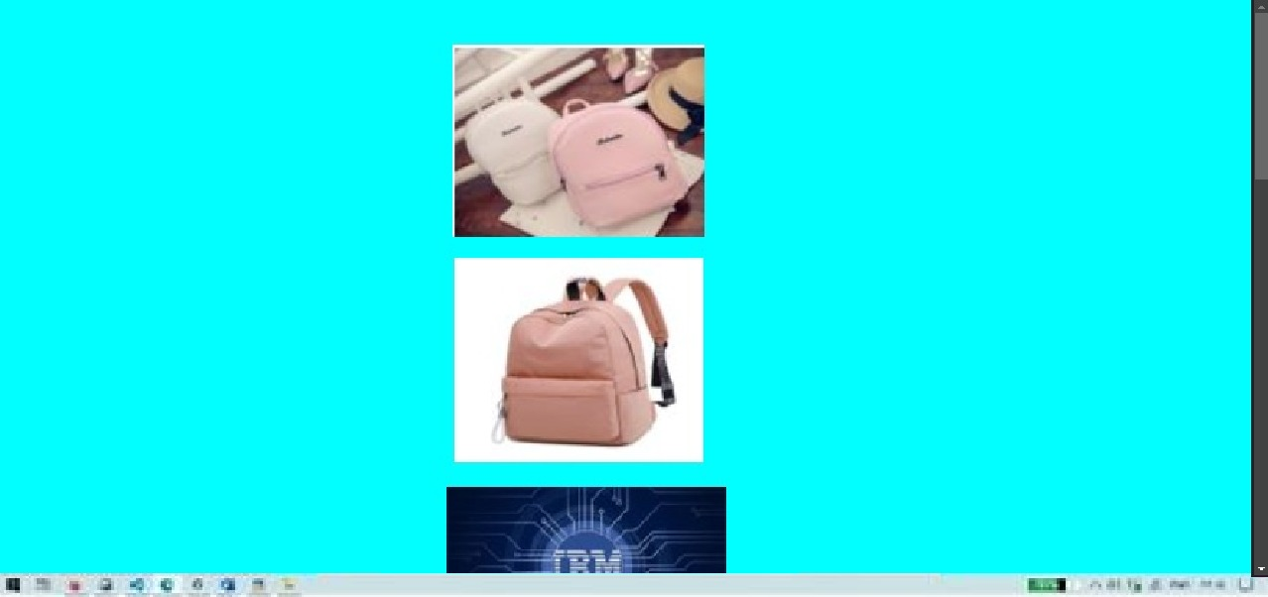

4) Design a Chatbot using IBM Watson assistant for hospital. Ex: User comes with query to know the branches for that hospital in your city. Submit the web URL of that chat bot as a assignment.

CHATBOT :

<https://web-chat.global.assistant.watson.appdomain.cloud/preview.html?backgroundImageURL=https%3A%2F%2Fus-south.assistant.watson.cloud.ibm.com%2Fpublic%2Fimages%2Fupx-4764f82f-2cc7-4d81-8e65-141b785791d9%3A%3A453e6180-c163-4821-91ef-0dd9c1e99db3&integrationID=f66ecb14-2407-452e-9b10-7bf1b4b9957b&region=us-south&serviceInstanceID=4764f82f-2cc7-4d81-8e65-141b785791d9>

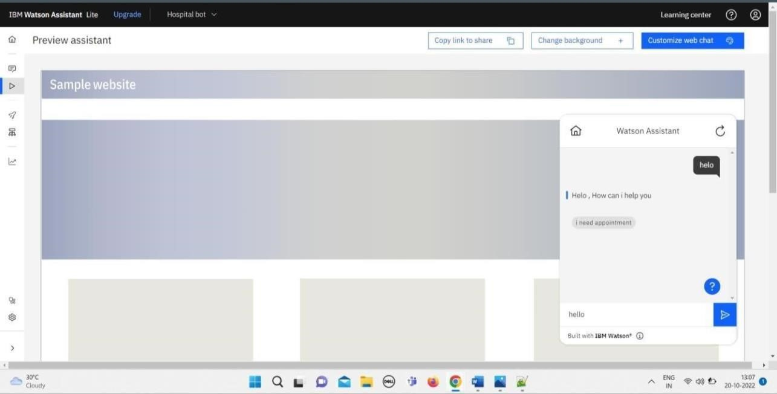

5)Create Watson assistant service with 10 steps and use 3 conditions in it. Load that script in

HTML page.

